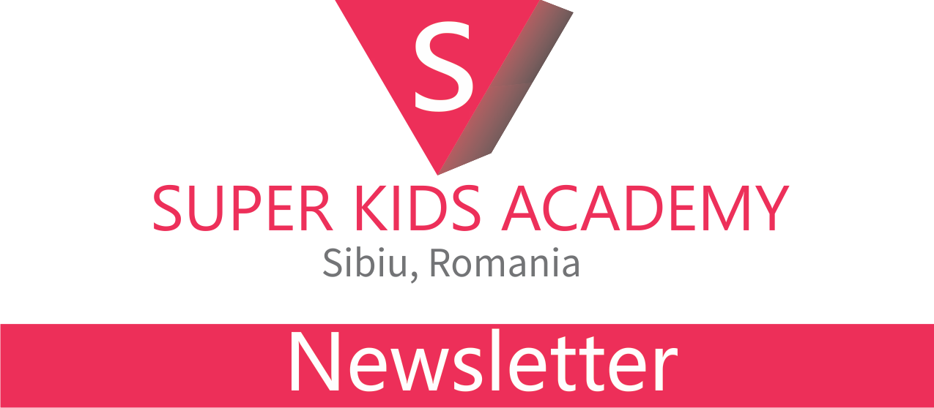

Women’s day
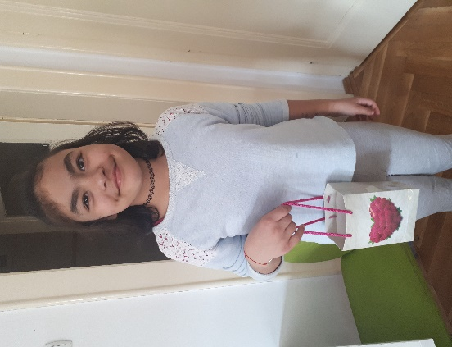
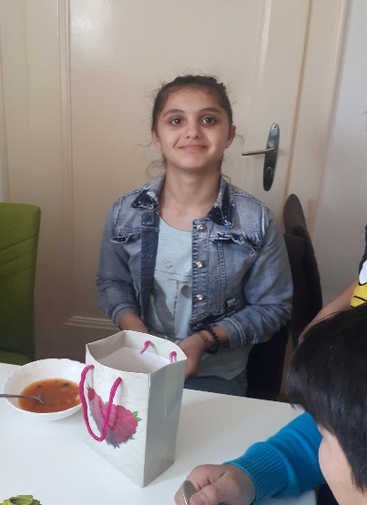
8 March is the Women’s day in Romania, and we have celebrated together with our female volunteers and girls. Each one received a small present.
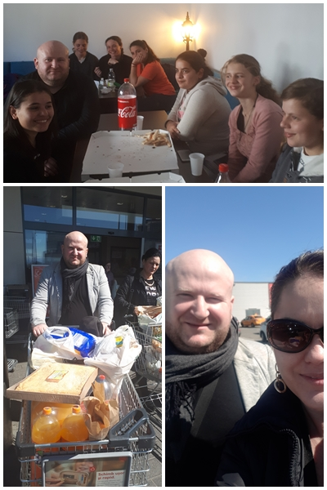
Visits
- Daniel Muntean, one of our friends from Cluj, came to visit us and did shopping for the children and bought for them Mc Donald’s and pizza. He has spent with us three days and the children were happy to see him.
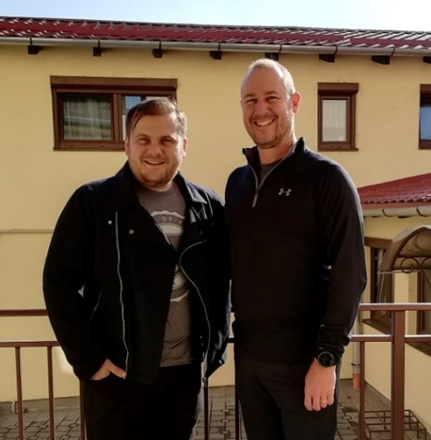

- We have received also the visit of Rob Pennison, that visited us last year also. He had spent time with the children and thought the teenagers.

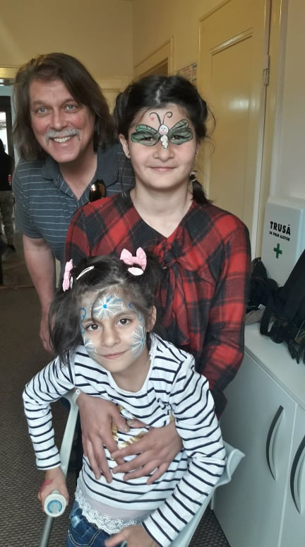
- Every year or even twice per year, pastor Barry Kidwell from First Centenary United Methodist Church come to visit us. This time he brought one of his friends, Bob, with him. It was such a joy seeing him again! We have organized a party for the children with this occasion.

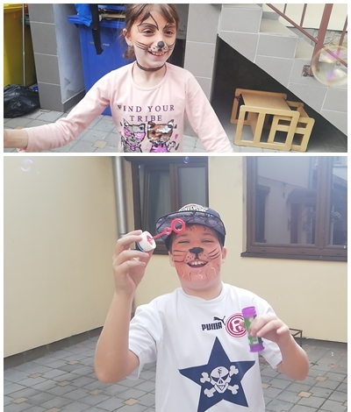
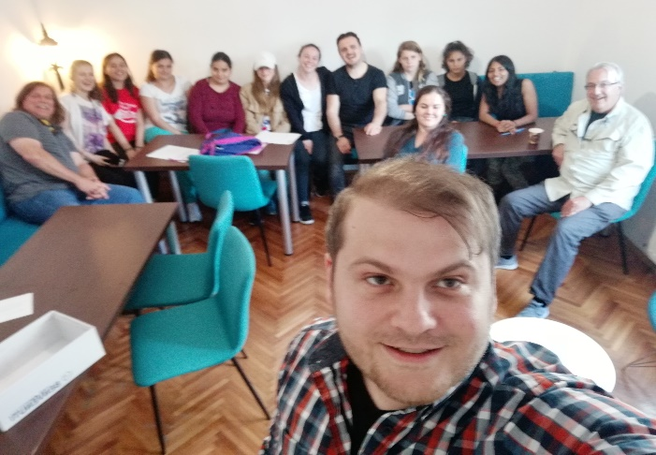
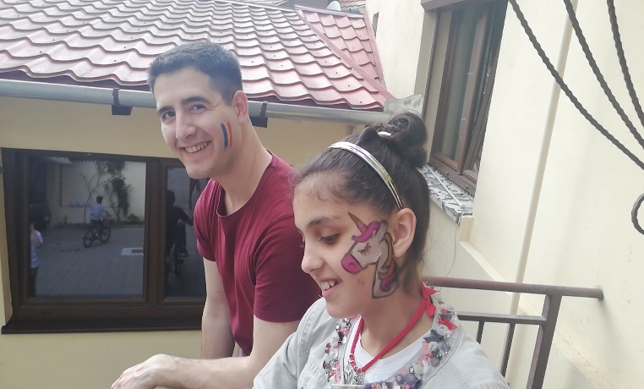
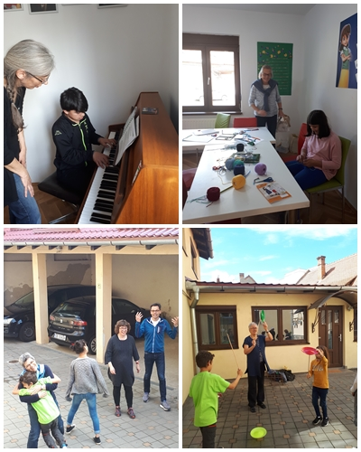
- We were also visited by a lovely team from Connexio, an organization that acts on behalf of the United Methodist Church in Switzerland and France. The team was led by Regina Hauenstein and has spent one day at the children center, playing, doing crafts, eating and talking with the kids.

Easter
In April we have celebrated Easter. In 27 April it was the Holy Thursday and we have commemorated the dead of our Lord, Jesus Christ. With this occasion, the children had a special program in the Cathedral. In 29 we have celebrated the happy day of Resurrection with the children at the orphanage and we had a nice meal together.

